JCCB BASS TOURNAMENT OFFICIAL ENTRY FORM
Name #1____________________________ Address:____________________________ City:________________State:___Zip:____ Phone # (s)__________________________ Emergency Contact:___________________ Email:______________________________
Name #2____________________________ Address:____________________________ City:________________State:___Zip:____ Phone # (s)__________________________ Emergency Contact:___________________ Email:______________________________
NOTE: This is not an individual tournament – you must have a team partner to participate
Make checks payable to: JCC Bassmasters
Mail to:
JCCB Bass Tournament c/o Brett Minor 10531Milton Ct. Fishers, IN 46040
I have read and understand the official rules of this tournament. I will obey all rules and understand that any violation may result in immediate disqualification without refund of my entry fee and forfeiture of any money or awards won. Having acquainted myself with the rules, I have completed this application and I am enclosing my entry fee payable to JCC Bassmasters. In signing this application, I hereby waive and release all other contestants, the Host Sponsors and Tournament Officials from all claims or injury and or damage incurred in connection with the tournament. I further understand and agree that the Tournament Committee reserves the right to refund this entry fee if it shall choose for any reason not to accept my application. Signature #1:________________________Date:___________ Signature #2:________________________Date:___________
Club officers:
Doug Lubs 317-557-5525 Todd Taylor 317-514-0850 Troy Gorham 317-435-2130 Brett Minor 317-373-9939 Rex Harris 317-509-8632 Jeff Terrell 317-697-7811
A SPECIAL THANKS TO OUR SPONSORS:
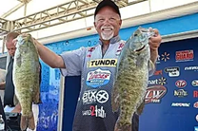
Bill Mcdonald Fishing - FLW Pro


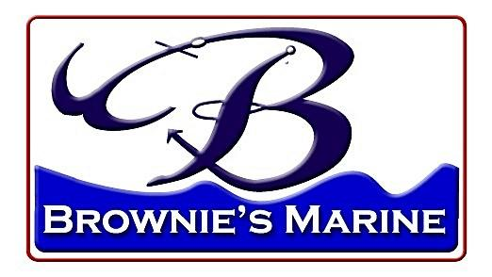


BASS TOURNAMENT
Johnson county christian bassmasters
www.jccbassmasters.com
TWENTIETH ANNUAL
TWO - MAN TEAM
gENE gREEN mEMORIAL BASS TOURNAMENT
GEIST RESERVOIR
AUGUST 22, 2020
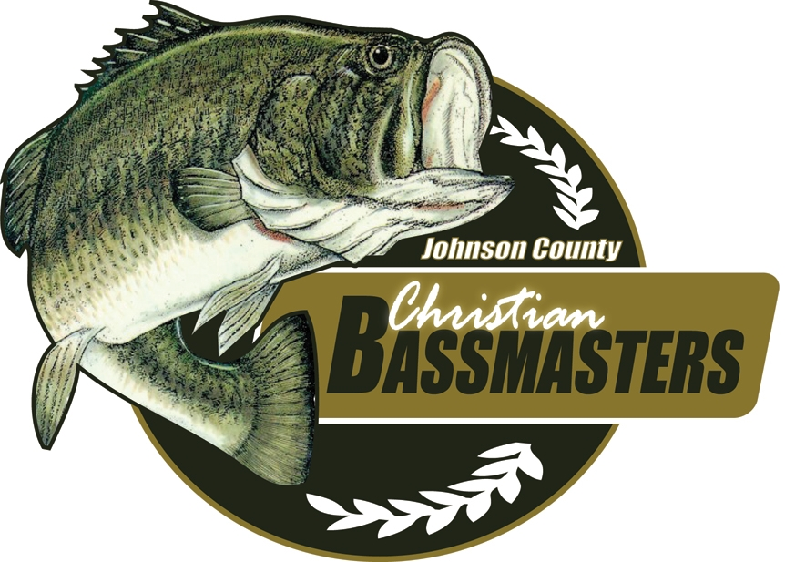
PURPOSE STATEMENT
The bass fishermen of JCC Bassmasters seek to proclaim the saving gospel of our Lord and Savior Jesus Christ, disciple and mentor men and promote Christian fellowship through the great sport of bass fishing.
Jesus said: “Follow me, and I will make you fishers of men.” Matt. 4:19
TOURNAMENT INFORMATION
- Entry fee is $90.00 per team by 08-15-20. Late entries are $100.00.
- Big Bass award entry is $5.00 per person and is included in the $90.00 entry fee.
- Boat checks will be conducted from 4:30-5:15 AM. Ramp meeting at 5:20 AM
- Staggered start will begin at 6:00 AM at idle speed only.
- Weigh-in is back at the ramp at 11:00 AM.
- There is a five (5) Bass limit per team (five total bass – not five each).

AWARDS ** 80% PAYOUT **
- There will be food and Awards at the Geist Ramp immediately following the weigh-in. All plaques, cash awards and door prizes will be given out there. You must be present to receive any award or prize – no exceptions!
- Individual plaques for 1st, 2nd & 3rd place teams & largest Bass.
- Cash awards for 1st, 2nd, 3rd & 4th place teams (Amounts based on number of entries).
- Cash award for biggest Bass (Size of award based on number entered).
- Door Prizes: Random ticket drawing of those present who fished the tournament. There will be some really nice prizes given out!
JCCB BASS TOURNAMENT RULES
Participation and Eligibility: Every boat must have at least one adult team member (18 years of age and up). Entry deadline is seven (7) days prior to the tournament date. A completed entry form with entry fee must be postmarked no later than the entry deadline or may be given to any club officer in person. Walk-ups permitted at $100 per boat.
Registration: Each competitor must register in person during the boat check period (4:30-5:15 AM EDT). Failure to register will result in a two (2) pound penalty for your team.
Team Pairing: Two-man teams must be paired prior to the tournament. This is not an individual tournament. You must have a team partner to participate.
Safety: Safe boating must always be observed. Each competitor is required to wear a Coast Guard approved life preserver. The preserver must be worn anytime the combustion engine is in operation; beginning at the time your boat is officially checked-in until your fish are weighed. All boats over 10 hp must have an emergency shut-off device that is securely attached to the driver’s body whenever the combustion engine is in operation.
Sportsmanship: Competitors in the JCCB tournament are expected to follow high standards of sportsmanship, courtesy and conservation. As Christians, we are representing our church, our Lord, and our own personal testimonies. Maximum courtesy must always be practiced, especially with regard to boating and angling in the vicinity of non-competitors. Any act that reflects unfavorably on these standards may be reason for disqualification. Alcoholic beverages and/or illegal drugs are prohibited.
Tackle and Equipment: All Bass must be caught alive in a conventional sporting manner. Only artificial lures may be used. No live bait or cut bait (except for pork trailers). Only one fishing rod may be used at a time. Trolling is not permitted as a method of fishing.
Permitted fishing locations: Competitors may fish anywhere on tournament waters accessible by boat and approved by the Tournament Director. All angling must be done from the boat. Competitors must not leave the boat to land a fish or to make the boat more accessible to the waters. Competitors must launch at the Olio Road ramp. The boat must remain in the tournament waters during the tournament day. Competitors must leave and return to official checkpoint by boat. Both competitors must always remain in the boat except in the case of an emergency.
Scoring: Tournament standings, awards and final winners shall be determined by the pounds and hundredths weight of each team’s catch during the day of the tournament. Only Largemouth, Spotted or Smallmouth Bass are accepted for weigh-in. The limit will be five (5) fish total per team. Any competitors who possess more than the tournament limit at any time during the tournament will have their catch disqualified. The minimum size limit is fourteen (14) inches. Any Bass presented for weigh-in that does not meet the minimum size limit will result in a penalty of one (1) pound for each such non-legal fish and that fish will not be weighed.
Care of the Fish: Each team is expected to keep their Bass alive by use of a properly aerated livewell. The penalty for each Bass weighed in dead shall be ¼ (.25) pound, which will be deducted from the total weight.
Late Penalty: Teams who are not at the official check-in point at the appointed time will be penalized at the rate of one (1) pound per minute deducted from the total weight, including any weight to be counted toward a Big Bass award. Any team more than fifteen (15) minutes late will be disqualified.
Ties: In the event of a tie for any position, the tiebreakers will be as follows: (1) Most fish (2) Biggest Bass (3) Coin flip.

